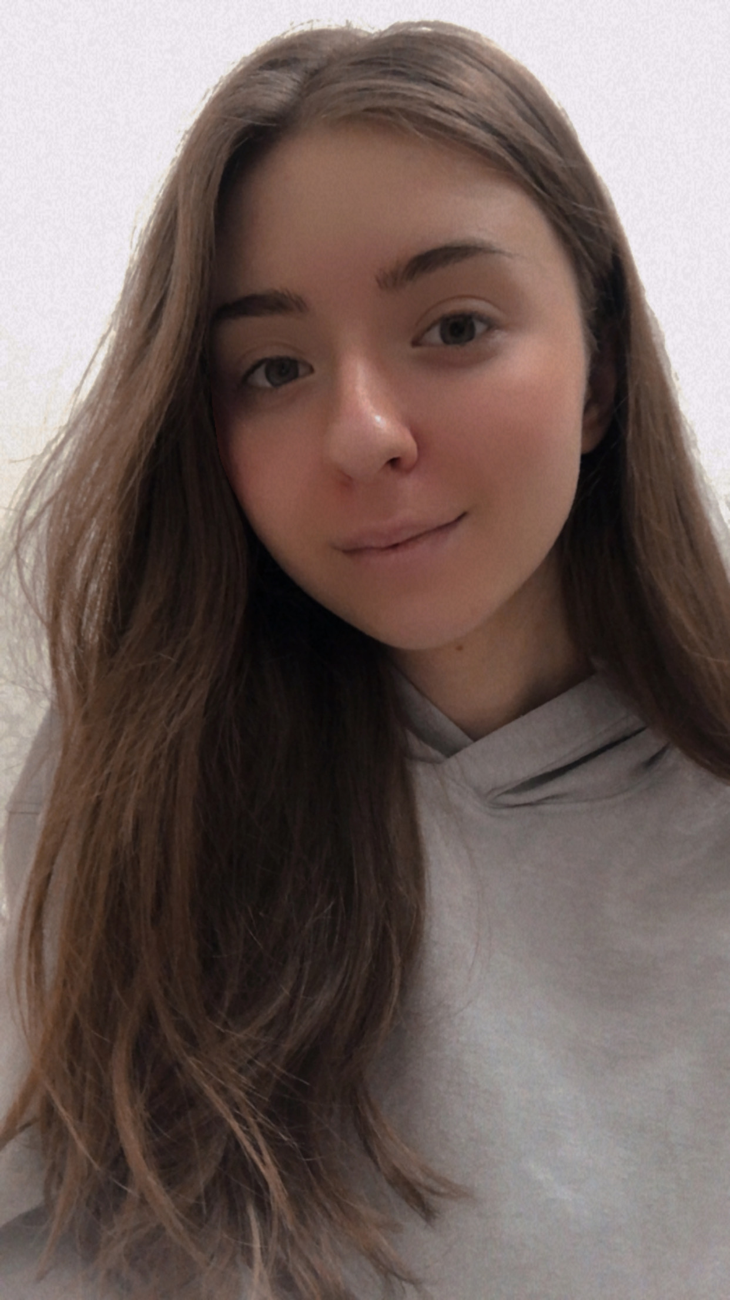
CURRICULUM VITAE

Personal details
Full name: Valeria Krupnova
Date of birth: 10 September 2001

Affiliation
Chair of Human and Animals Physiology, Biology Department, Saratov State University, 410012, Astrakhanskaya str., 83, Saratov, Russia.
E-mail: krupnova_0110@mail.ru

Education
2019-2023 Student, Chair of Human and Animals Physiology, Biology Department, Saratov State University
2023-now Magistracy, Biology Department, Saratov State University

Employment
2021- now Laboratory assistant, Chair of Human and Animals Physiology, Biology Department, Saratov State University

Specialization
06.04.01 – Biology
Research interests
The cerebral lymphatic system; neuroimmunology, brain drug delivery, neurophotonics.
Education activity
Lectures of basic courses:
1. Physiology of Human and Animals
2. Physiology of Central Nervous System
3. Biochemistry
4. Cellular and molecular physiology
5. Biophysics
Special courses:
1. Sleep: Neuroscience, Medicine and Society
2. The basic principles of light microscopy and its practical application in biology
3. Experimental medicine and preclinical research of medicines

Grants
Grant from Russian Science Foundation № 23-75-30001
“Pilot technology for photomodulation of the immune system of the animal and human brain: innovative strategies in the treatment of Alzheimer's disease” (leading investigator)

Main publications
1. Oxana Semyachkina-Glushkovskaya, Konstantin Sergeev, Nadezhda Semenova, Andrey Slepnev, Anatoly Karavaev, Alexey Hramkov, Mikhail Prokhorov, Ekaterina Borovkova, Inna Blokhina, Ivan Fedosov, Alexander Shirokov, Alexander Dubrovsky, Andrey Terskov, Maria Manzhaeva, Valeria Krupnova, Alexander Dmitrenko, Daria Zlatogorskaya, Viktoria Adushkina, Arina Evsukova, Matvey Tuzhilkin, Inna Elizarova, Egor Ilyukov, Dmitry Myagkov, Dmitry Tuktarov, Jürgen Kurths. Machine learning technology for EEG-forecast of the blood-brain barrier leakage and the activation of brain’s drainage system during isoflurane anesthesia. Biomolecules. 2023. 13, 1605. https://doi.org/10.3390/biom13111605
Impact factor – 5.5 (Q1)
2. Oxana Semyachkina-Glushkovskaya, Konstantin Sergeev, Nadezhda Semenova, Andrey Slepnev, Anatoly Karavaev, Alexey Hramkov, Mikhail Prokhorov, Ekaterina Borovkova , Inna Blokhina, Ivan Fedosov, Alexander Shirokov, Alexander Dubrovsky, Andrey Terskov, Maria Manzhaeva, Valeria Krupnova , Alexander Dmitrenko, Daria Zlatogorskaya, Viktoria Adushkina, Arina Evsukova, Matvey Tuzhilkin, Inna Elizarova , Egor Ilyukov , Dmitry Myagkov , Dmitry Tuktarov and Jürgen Kurths. Technology of photobiostimulation of brain’s drainage system during sleep for improvement of learning and memory in male mice. Biomedical Optics Express. 2023 (accepted)
Impact factor – 3.56 (Q1)
3. Oxana Semyachkina-Glushkovskaya, Ivan Fedosov, Alexey Zaikin, Vasily Ageev, Egor Ilyukov, Dmitry Myagkov, Dmitry Tuktarov, Inna Blokhin, Alexander Shirokov, Andrey Terskov, Daria Zlatogorskaya, Viktoria Adushkina, Arina Evsukova, Alexander Dubrovsky, Maria Tsoy, Valeria Telnova, Maria Manzhaeva, Alexander Dmitrenko, Valeria Krupnova, Jürgen Kurths. Different effects of phototherapy of rat glioma during sleep and wakefulness. Biomedicine. 2024 (under review)
Impact factor – 4.7(Q1)
4. Shirokov Alexander, Blokhina Inna, Fedosov Ivan, Ilukov Egor, Terskov Andrey, Dubrovsky Alexander, Tsoy Maria, Zlatogosrskaya Daria, Adushkina Viktoria, Evsukova Arina, Telnova Valeria, Krupnova Valeria, Manzhaeva Maria, Dmitrenko Alexander, Magkov Dmitry, Tuktarov Dmitry, Penzel Thomas, Kurths Jürgen, Semyachkina-Glushkovskaya Oxana. 5-aminolevulinic acid-mediated photodynamic effects on functions of the meningeal lymphatics. Biomedical Optics Express. 2023 (under review)
Impact factor – 3.56 (Q1)
5. Terskov Andrey, Shirokov Alexander, Blokhina Inna, Zlatogosrskaya Daria, Adushkina Viktoria, Evsukova Arina, Telnova Valeria, Krupnova Valeria, Manzhaeva Maria, Dmitrenko Alexander, Fedosov Ivan, Ilukov Egor, Dubrovsky Alexander, Tsoy Maria, Magkov Dmitry, Tuktarov Dmitry, Kurths Jürgen, Semyachkina-Glushkovskaya. Phototherapy of glioblastoma and sleep. The European Physical Journal: Special Topics. 2024 (in publish)
Impact factor – 2.891 (Q2)

