CURRICULUM VITAE

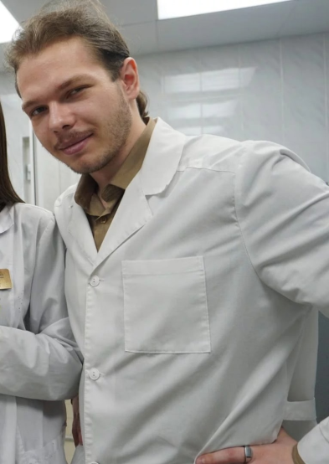
Personal details
Full name: Tuzhilkin Matvey
Date of birth: 29 April 2003

Affiliation
Biology Department, Chair of Human and Animal Physiology,
Saratov State University, 410012,
Astrakhanskaya str., 83, Saratov, Russia.
E-mail: TuzhilkinMA@yandex.ru

Education
2020-2024 Bachelor student, Chair of Human and Animal Physiology,
Biology Department, Saratov State University
Specialization
06.03.01 – Biology
Research interests

The cerebral lymphatic system; neuroimmunology, brain drug delivery, neurophotonics, anesthesiology, electroencephalography.

Employment
2023 – now Laboratory assistant in the Laboratory of Smart Sleep of Scientific Medical Center at the Saratov State University. Job description: surgery, conducting chronic and acute experiments on animals.
Grants
Grant from Russian Science Foundation № 23-75-30001
“Pilot technology for photomodulation of the immune system of the animal and human brain: innovative strategies in the treatment of Alzheimer's disease” (leading investigator)
Role in this project: EEG system development, development technology for photobiomodulation of the immune system of the animal brain, conducting experiments.
Main publications
- Oxana Semyachkina-Glushkovskaya, Konstantin Sergeev, Nadezhda Semenova, Andrey Slepnev, Anatoly Karavaev, Alexey Hramkov, Mikhail Prokhorov, Ekaterina Borovkova, Inna Blokhina, Ivan Fedosov, Alexander Shirokov, Alexander Dubrovsky, Andrey Terskov, Maria Manzhaeva, Valeria Krupnova, Alexander Dmitrenko, Daria Zlatogorskaya, Viktoria Adushkina, Arina Evsukova, Matvey Tuzhilkin, Inna Elizarova, Egor Ilyukov, Dmitry Myagkov, Dmitry Tuktarov, Jürgen Kurths. Machine learning technology for EEG-forecast of the blood-brain barrier leakage and the activation of brain’s drainage system during isoflurane anesthesia. Biomolecules. 2023. 13, 1605. https://doi.org/10.3390/biom13111605
Impact factor – 5.5 (Q1)

- Oxana Semyachkina-Glushkovskaya, Konstantin Sergeev, Nadezhda Semenova, Andrey Slepnev, Anatoly Karavaev, Alexey Hramkov, Mikhail Prokhorov, Ekaterina Borovkova , Inna Blokhina, Ivan Fedosov, Alexander Shirokov, Alexander Dubrovsky, Andrey Terskov, Maria Manzhaeva, Valeria Krupnova , Alexander Dmitrenko, Daria Zlatogorskaya, Viktoria Adushkina, Arina Evsukova, Matvey Tuzhilkin, Inna Elizarova , Egor Ilyukov , Dmitry Myagkov , Dmitry Tuktarov and Jürgen Kurths. Technology of photobiostimulation of brain’s drainage system during sleep for improvement of learning and memory in male mice. Biomedical Optics Express. 2023 (accepted)
Impact factor – 3.56 (Q1)

- Blokhina IA, Koronovskii AA Jr, Dmitrenko AV, Elizarova IV, Moiseikina TV, Tuzhilkin MA, Semyachkina-Glushkovskaya OV, Pavlov AN. Characterization of Anesthesia in Rats from EEG in Terms of Long-Range Correlations. Diagnostics (Basel). 2023 Jan 24;13(3):426. doi: 10.3390/diagnostics13030426.
Impact factor – 3.992(Q2)

- Koronovskii AA Jr, Blokhina IA, Dmitrenko AV, Tuzhilkin MA, Moiseikina TV, Elizarova IV, Semyachkina-Glushkovskaya OV, Pavlov AN. Extended Detrended Fluctuation Analysis of Coarse-Grained Time Series. Diagnostics (Basel). 2022 Dec 28;13(1):93. doi: 10.3390/diagnostics13010093.
Impact factor – 3.992 (Q2)

