CURRICULUM VITAE
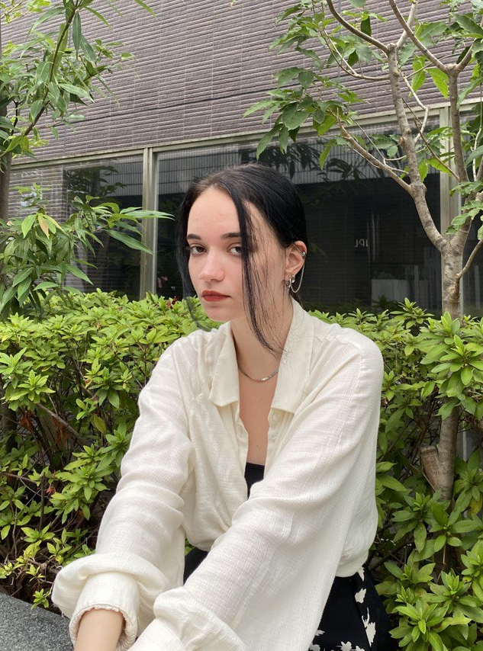
Personal details
Full name: Zlatogorskaya (Elovenko) Daria Andreevna
Date of birth: 8 March 2000

Affiliation
Engineer of Chair of Human and Animals Physiology, Biology Department,
Saratov State University, 410012,
Astrakhanskaya str., 83, Saratov, Russia.
E-mail: eloveda@mail.ru
Education
2018-2022 Bachelor Student, Chair of Human and Animals Physiology,
Biology Department, Saratov State University
2022-2024 Master's degree student, Chair of Human and Animals Physiology,
Biology Department, Saratov State University
Specialization
06.03.01 – biology
06.04.01 – modern technologies for visualization and analysis of living systems

Research interests
The cerebral lymphatic system; electrophysiology; animal phenotyping; behavior; EEG; brain drug delivery, BBB.

Education activity
Lectures of basic courses:
- Physiology of Human and Animals
- Physiology of Central Nervous System
- Cellular and molecular physiology
- Biophysics
Special courses:
- The use of bioinformatics methods in biological and medical research;
- Optics and theory of optical systems;
- Computer technologies and mathematical modeling in biology.
Employment
2019-2021 Zoological Museum laboratory assistant, Biology Department, Saratov State University
2021-2022 Laboratory assistant to the Chair of Human and Animals Physiology, Biology Department, Saratov State University.
2023 now Engineer of Chair of Human and Animals Physiology and Engineer in the Laboratory of Smart Sleep of Scientific Medical Center at the Saratov State University. Job description: animal phenotyping.

Grants
2019-2023 Governmental grant No 075-15- 2019-1885 «Discovery of fundamental
mechanisms of sleep for breakthrough technologies of neurorehabilitation medicine». (R). Role in this project: participation in experiments, surgery.
2023-2026 Grant from Russian Science Foundation № 23-75-30001 “Pilot technology for photomodulation of the immune system of the animal and human brain: innovative strategies in the treatment of Alzheimer's disease” (R). Role in this project: participation in experiments, animal phenotyping.

Main publications
1. Semyachkina-Glushkovskaya O.V., Karavaev A.S., Prokhorov M.D., Runnova A.E., Borovkova E.I., Ishbulatov Yu.M., Hramkov A.N., Kulminskiy D.D., Semenova N.I., Sergeev K.S., Slepnev A.V., Sitnikova E.Yu., Zhuravlev M.O., Fedosov I.V., Shirokov A.A., Blokhina I.A. Dubrovski A.I., Terskov A.V., Khorovodov A.P., Ageev V.B., Elovenko D.A., Evsukova A.S., Adushkina V.V., Telnova V.V., Postnov D.E., Penzel T., Kurths J. EEG biomarkers of activation of the lymphatic drainage system of the brain during sleep and opening of the blood-brain barrier. Computational and Structural Biotechnology Journal 21 (2023) 758–768 https://doi.org/10.1016/j.csbj.2022.12.019
IF – 7.21 (Q1)
2. Oxana Semyachkina-Glushkovskaya, Alexander Shirokov, Inna Blokhina, Valeria Telnova, Elena Vodovozova, Anna Alekseeva, Ivan Boldyrev, Ivan Fedosov, Alexander Dubrovsky, Alexandr Khorovodov, Andrey Terskov, Arina Evsukova, Daria Elovenko, Viktoria Adushkina, Maria Tzoy, Ilana Agranovich, Jürgen Kurth, Edik Rafailov. Intranasal delivery of liposomes to glioblastoma by photostimulation of the lymphatic system. Pharmaceutics 2023, 15(1), 36; https://doi.org/10.3390/pharmaceutics15010036
IF – 6.29 (Q1)
3. Semyachkina-Glushkovskaya, O.; Bragin, D.; Bragina, O.; Socolovski, S.; Shirokov, A.; Fedosov, I.; Ageev, V.; Blokhina, I.; Dubrovsky, A.; Telnova, V.; Terskov, A.; Khorovodov, A.; Elovenko, D.; Evsukova, A.; Zhoy, M.; Agranovich, I.; Vodovozova, E.; Alekseeva, A.; Kurths, J.; Rafailov, E. Low-Level Laser Treatment Induces the BloodBrain Barrier Opening and the Brain Drainage System Activation: Delivery of Liposomes into Mouse Glioblastoma. Pharmaceutics 2023, 15, 567. https://doi.org/10.3390/pharmaceutics15020567
IF – 6.29 (Q1)
4. Oxana Semyachkina-Glushkovskaya, Thomas Penzel, Inna Blokhina, Alexander Khorovodov, Ivan Fedosov, Tingting Yu, Georgy Karandin, Arina Evsukova, Daria Elovenko, Viktoria Adushkina, Alexander Shirokov, Alexander Dubrovsky, Andrey Terskov, Nikita Navolokin, Maria Tzoy, Vasily Ageev, Ilana Agranovich, Valeria Telnova, Anna Tsven2, Jürgen Kurths. Night photostimulation of clearance of beta-amyloid from mouse brain: new strategies in preventing Alzheimer’s disease. Cells 2021, 10(12), 3289; https://doi.org/10.3390/cells10123289
IF – 6.6 (Q1)
5. Semyachkina-Glushkovskaya O, Diduk S, Anna E, Elina D, Artem K, Khorovodov A, Shirokov A, Fedosov I, Dubrovsky A, Blokhina I, Terskov A, Navolokin N, Evsukova A, Elovenko D, Adushkina V, Kurths J. (2022) Music improves the therapeutic effects of bevacizumab in rats with glioblastoma: Modulation of drug distribution to the brain. Front. Oncol. 2022. 12:1010188. doi: 10.3389/fonc.2022.1010188
IF – 5.738 (Q1)
6. Oxana Semyachkina-Glushkovskaya, Konstantin Sergeev, Nadezhda Semenova, Andrey Slepnev, Anatoly Karavaev, Alexey Hramkov, Mikhail Prokhorov, Ekaterina Borovkova, Inna Blokhina, Ivan Fedosov, Alexander Shirokov, Alexander Dubrovsky, Andrey Terskov, Maria Manzhaeva, Valeria Krupnova, Alexander Dmitrenko, Daria Zlatogorskaya, Viktoria Adushkina, Arina Evsukova, Matvey Tuzhilkin, Inna Elizarova, Egor Ilyukov, Dmitry Myagkov, Dmitry Tuktarov, Jürgen Kurths. Machine learning technology for EEG-forecast of the blood-brain barrier leakage and the activation of brain’s drainage system during isoflurane anesthesia. Biomolecules. 2023. 13, 1605. https://doi.org/10.3390/biom13111605
IF – 5.5 (Q1)
7. Oxana Semyachkina-Glushkovskaya, Ivan Fedosov, Alexey Zaikin, Vasily Ageev, Egor Ilyukov, Dmitry Myagkov, Dmitry Tuktarov, Inna Blokhin, Alexander Shirokov, Andrey Terskov, Daria Zlatogorskaya, Viktoria Adushkina, Arina Evsukova, Alexander Dubrovsky, Maria Tsoy, Valeria Telnova, Maria Manzhaeva, Alexander Dmitrenko, Valeria Krupnova, Jürgen Kurths. Different effects of phototherapy of rat glioma during sleep and wakefulness. Biomedicine. 2024 (under review)
IF – 4.7(Q1)
8. Oxana Semyachkina-Glushkovskaya, Konstantin Sergeev, Nadezhda Semenova, Andrey Slepnev, Anatoly Karavaev, Alexey Hramkov, Mikhail Prokhorov, Ekaterina Borovkova, Inna Blokhina, Ivan Fedosov, Alexander Shirokov, Alexander Dubrovsky, Andrey Terskov, Maria Manzhaeva, Valeria Krupnova , Alexander Dmitrenko, Daria Zlatogorskaya, Viktoria Adushkina, Arina Evsukova, Matvey Tuzhilkin, Inna Elizarova , Egor Ilyukov , Dmitry Myagkov , Dmitry Tuktarov and Jürgen Kurths. Technology of photobiostimulation of brain’s drainage system during sleep for improvement of learning and memory in male mice. Biomedical Optics Express. 2023 (accepted)
IF – 3.56 (Q1)
9. Shirokov Alexander, Blokhina Inna, Fedosov Ivan, Ilukov Egor, Terskov Andrey, Dubrovsky Alexander, Tsoy Maria, Zlatogosrskaya Daria, Adushkina Viktoria, Evsukova Arina, Telnova Valeria, Krupnova Valeria, Manzhaeva Maria, Dmitrenko Alexander, Magkov Dmitry, Tuktarov Dmitry, Penzel Thomas, Kurths Jürgen, Semyachkina-Glushkovskaya Oxana. 5-aminolevulinic acid-mediated photodynamic effects on functions of the meningeal lymphatics. Biomedical Optics Express. 2023 (under review)
IF – 3.56 (Q1)
10. Terskov Andrey, Shirokov Alexander, Blokhina Inna, Zlatogosrskaya Daria, Adushkina Viktoria, Evsukova Arina, Telnova Valeria, Krupnova Valeria, Manzhaeva Maria, Dmitrenko Alexander, Fedosov Ivan, Ilukov Egor, Dubrovsky Alexander, Tsoy Maria, Magkov Dmitry, Tuktarov Dmitry, Kurths Jürgen, Semyachkina-Glushkovskaya. Phototherapy of glioblastoma and sleep. The European Physical Journal: Special Topics. 2024 (in publish)
IF – 2.891 (Q2)
11. Alexander Shirokov; Egor Ilukov; Inna Blokhina; Andrey Terskov; Viktoria Adushkina; Daria Zlatogosrkaya; Valeria Telnova. New insights into phototherapy of glioblastoma: the meningeal lymphatics and sleep. The European Physical Journal: Special Topics. 2024 (in publish)
IF – 2.891 (Q2)
12. Egor Ilukov, Dmitry Myagkov, Dmitry Tuktarov, Sergey Popov, Timofey Inozemtsev, Inna Blokhina, Andrey Terskov, Viktoria Adushkina, Daria Zlatogosrkaya. Task specific approach in customized design of EEG system for small laboratory animals. The European Physical Journal: Special Topics. 2024 (in publish)
IF – 2.891 (Q2)
13. Inna Blokhiba, Viktoria Adushkina, Daria Zlatogosrkaya, Egor Ilyukov, Valeria Telnova, Arina Evsyukova, Andrey Terskov, Dmitry Myagkov, Dmitry Tuktarov, Maria Tzoy, Alexander Dubrovsky, Alexander Dmitrenko, Maria Manzhaeva, Valeria Krupnova, Matvey Tuzhilkin, Inna Elezarova, Nikita Navolokin. Method for real-time optical brain monitoring in freely moving mice during wakefulness and natural sleep. The European Physical Journal: Special Topics. 2024 (in publish)
IF – 2.891 (Q2)

